Accessing Individual Characters in a String
In Python, characters in a string are stored in a sequence. We can access individual characters inside a string by using an index. An index refers to the position of a character inside a string. In Python, strings are 0 indexed, it means that the first character is at the index 0, the second character is at index 1 and so on. The index position of the last character is one less than the length of the string.
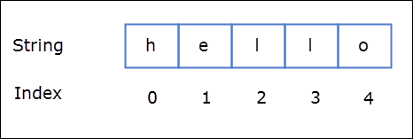
To access individual characters inside a string we type the name of the variable, followed by the index number of the character inside the square brackets [].
1  2  3  4  5  6  7  8  9  10  11  12  13  14 | >>>  >>> s1 = "hello"  >>>  >>> s1[0] # get the first character  'h'  >>> s1[1] # get the second character  'e'  >>> s1[2] # get the third character  'l'  >>> s1[3] # get the fourth character  'l'  >>> s1[4] # get the fifth character  'o'  >>>
Try it now
The last valid index for string s1 is 4, if you try to access characters beyond the last valid index you will get IndexError as follows:
1  2  3  4  5  6 | >>>  >>> s1[5] # get the sixth character  Traceback (most recent call last):  File "<stdin>", line 1, in <module>  IndexError: string index out of range  >>>
Try it now
Instead of manually counting the index position of the last character in the string, we can use the len() function to calculate the string and then subtract 1 from it to get the index position of the last character.
1  2  3  4  5  6 | >>>  >>> quote = "The best is the enemy of the good"  >>>  >>> quote[len(quote)-1]  'd'  >>>
Try it now
We can also use negative indexes. A negative index allows us to access characters from the end of the string. The negative index starts from -1, so the index position of the last character is -1, for the second last character it is -2 and so on.
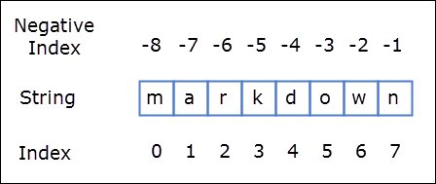
1  2  3  4  5  6  7  8  9  10  11  12  13  14  15 | >>>  >>> s = "markdown"  >>>  >>> s[-1] # get the last character  'n'  >>>  >>> s[-2] # get the second last character  'w'  >>>  >>> s[-8] # get the first character  'm'  >>>  >>> s[-len(s)] # get the first character  'm'  >>>
Try it now
If negative index is smaller than the last valid index (-8) then IndexError will occur as follows:
1  2  3  4  5  6 | >>>  >>> s[-9]  Traceback (most recent call last):  File "<stdin>", line 1, in <module>  IndexError: string index out of range  >>>

